**Exploratory Testing with Azure Test**

Step 1: Open **Azure DevOps Demo Generator**

<https://azuredevopsdemogenerator.azurewebsites.net/>

Click on **Sign In** button.

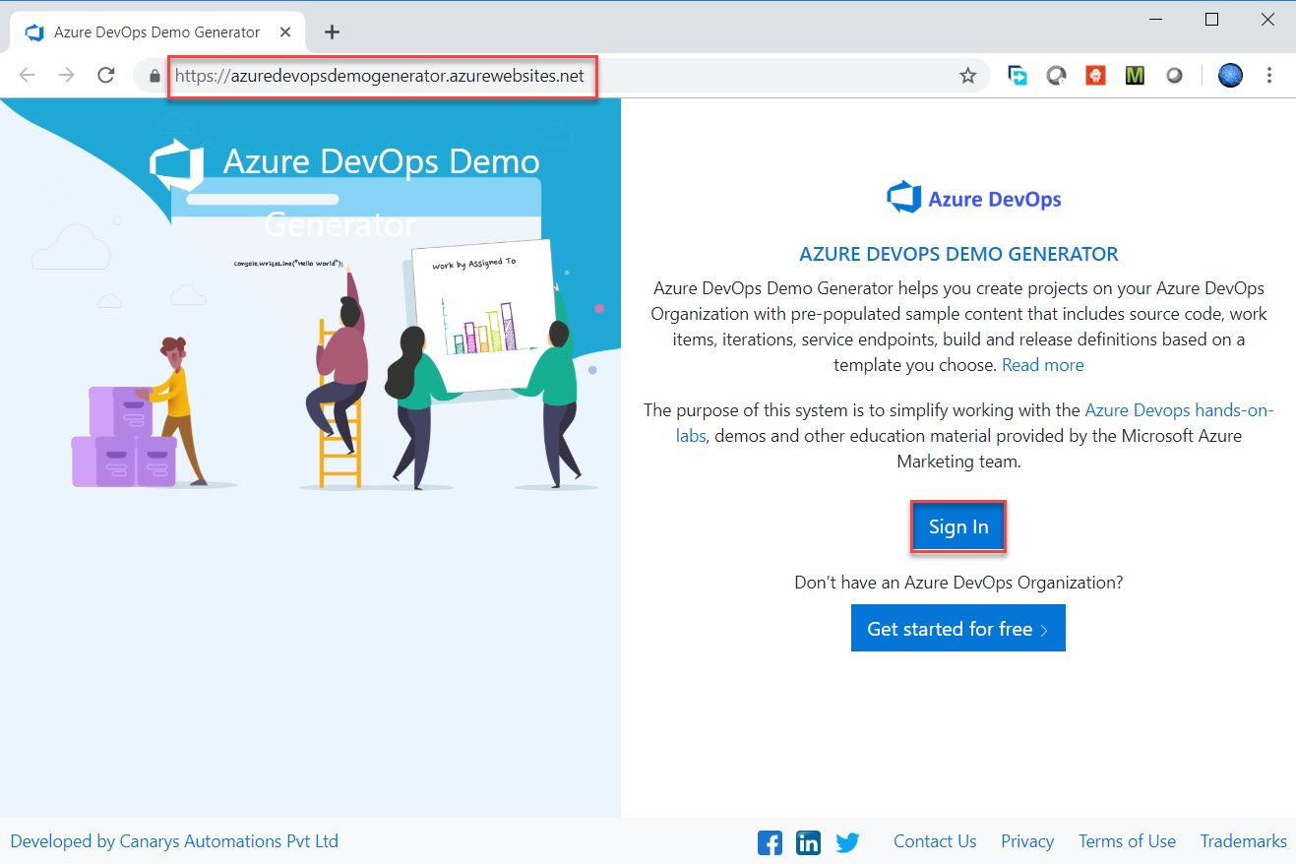

Step 2: Enter Azure DevOps credentials

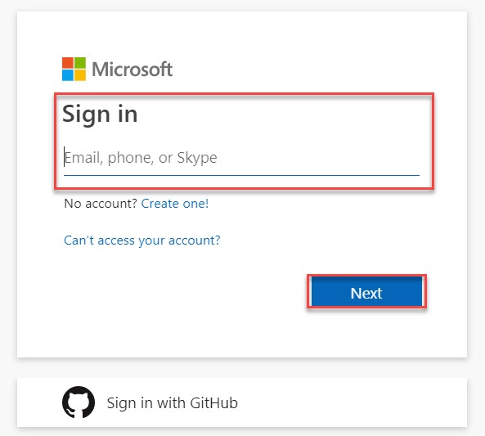

Step 3: Select **Organization**

Click on **Choose Template** option

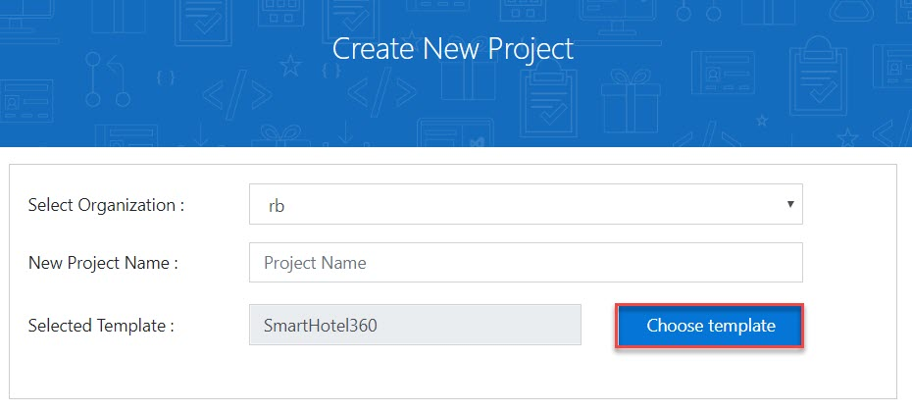

Step 4: Select **PartsUnlimited** template

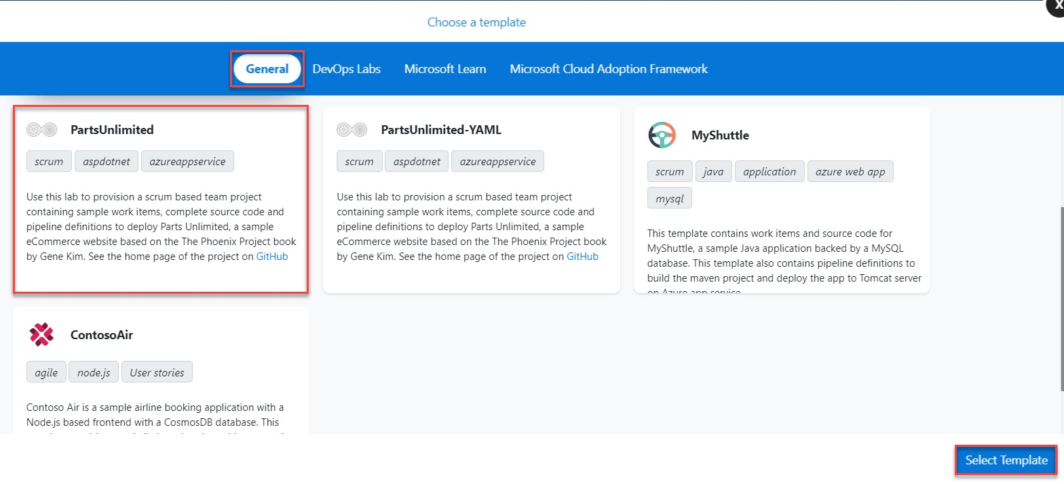

Step 5: Enter Project Name: **MyPartsUnlimitedProject** and Click on **Create Project**.

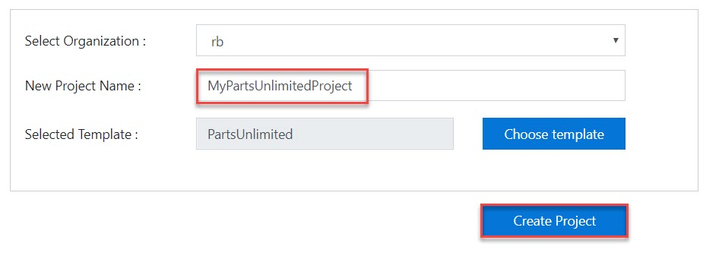

Step 6: Click on **Navigate to Project** button.

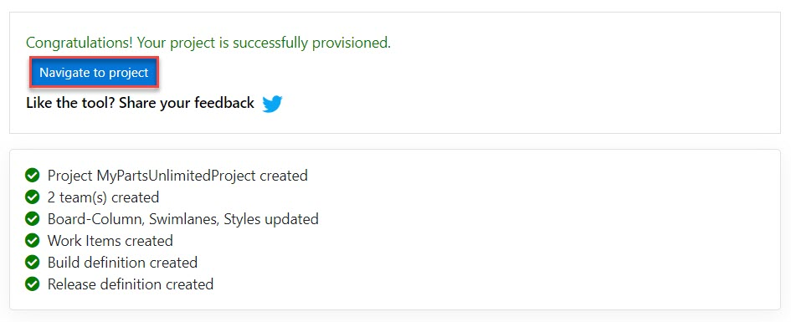

Step 7: Within few seconds Project will load as below:

Select **Browse marketplace** option.

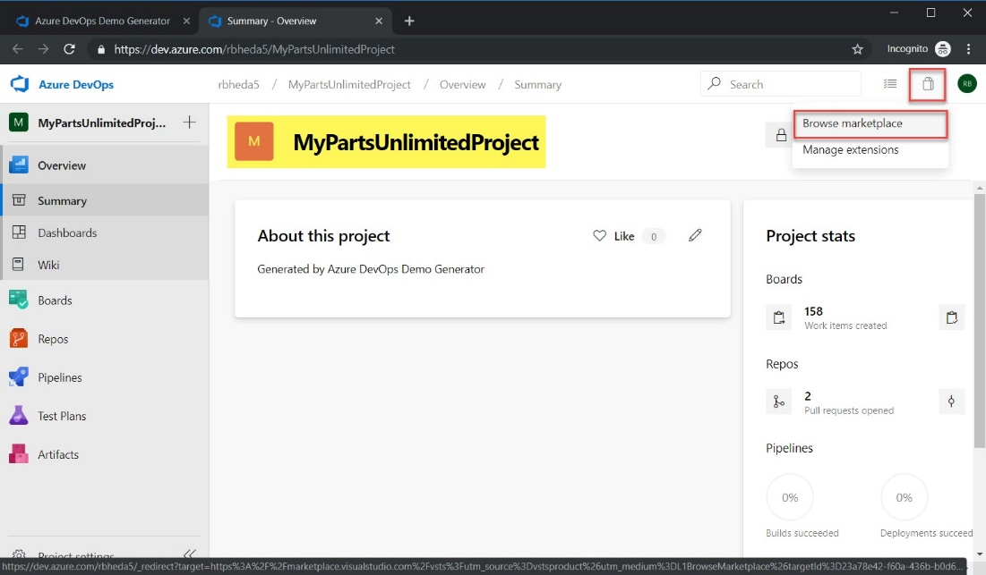

Step 8: search for feedback

Click on Test & Feedback

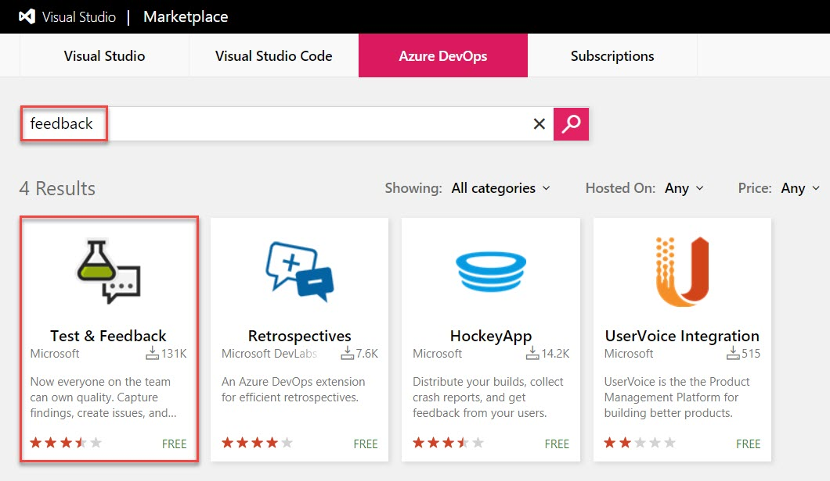

Step 9: Click on Install button

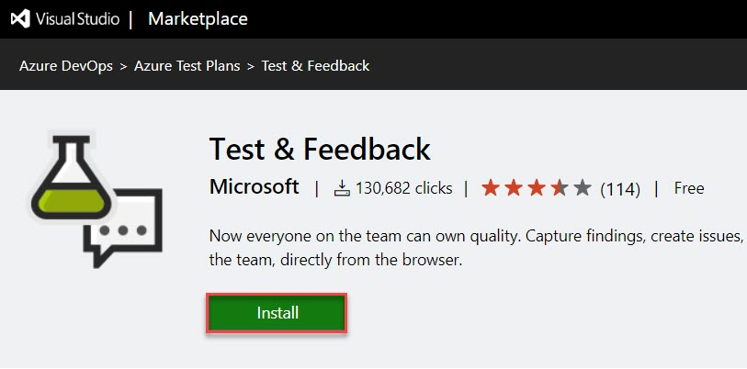

Step 10: Choose Preferred Browser. Ex. Chrome

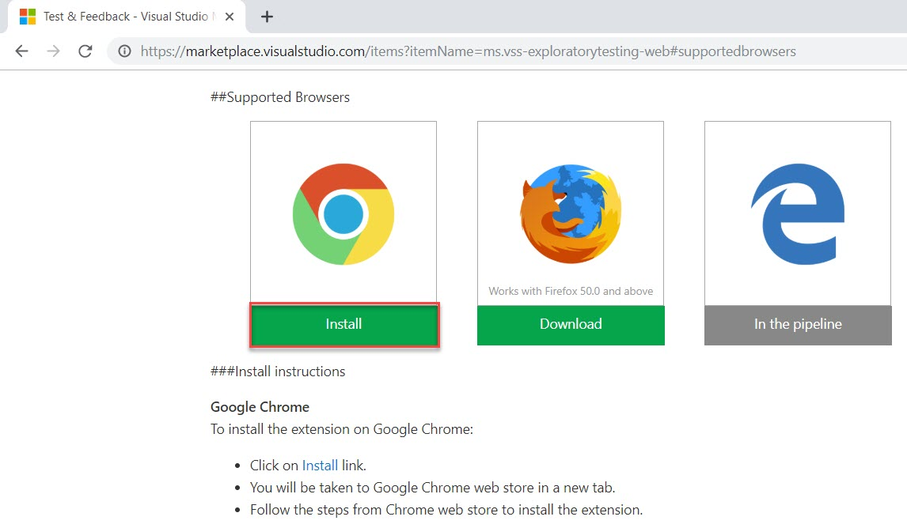

Step 11: Chrome Extension will load and click on Add to Chrome button.

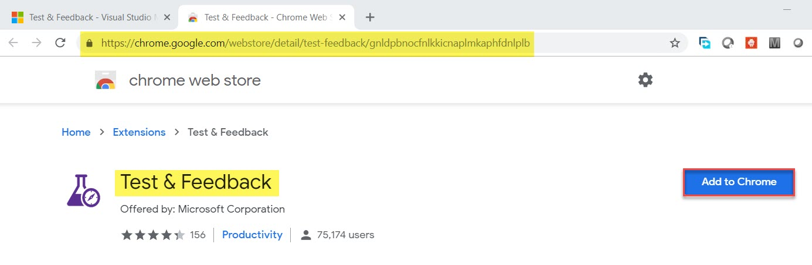

Step 12:

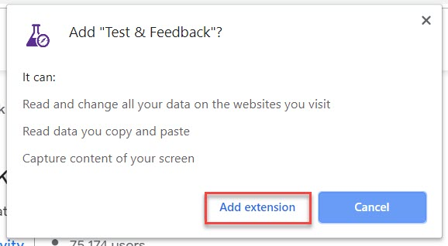

Step 13: Test & Feedback icon available

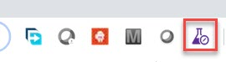

Step 14: Click on Icon -> Settings

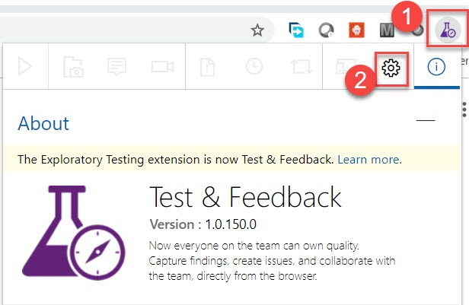

Step 15: Enter Connection String

Server URL: Enter Azure DevOps address. Ex. <https://dev.azure.com/username>

Click on Next button.

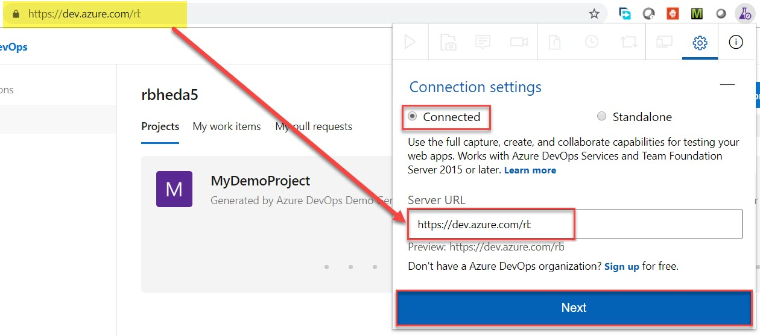

Step 16: Choose PartsUnlimited Project Team and click on Save button.

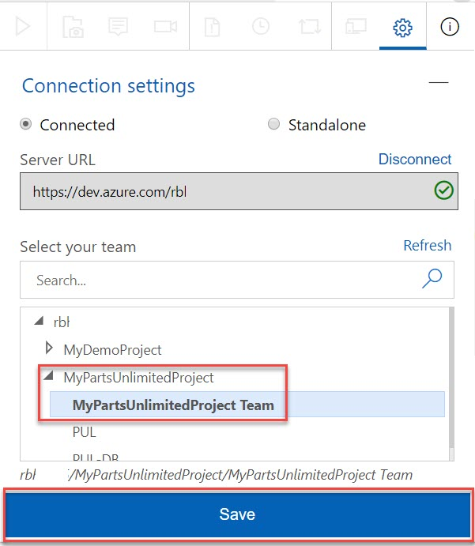

Step 17: Navigate to Azure Repos

Click on Clone option

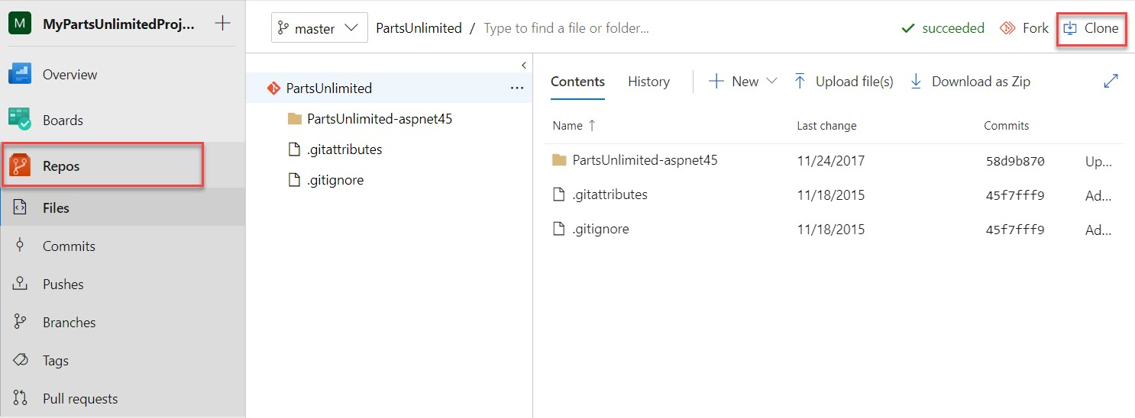

Step 18: Change IDE option to Visual Studio

Clone in Visual Studio option

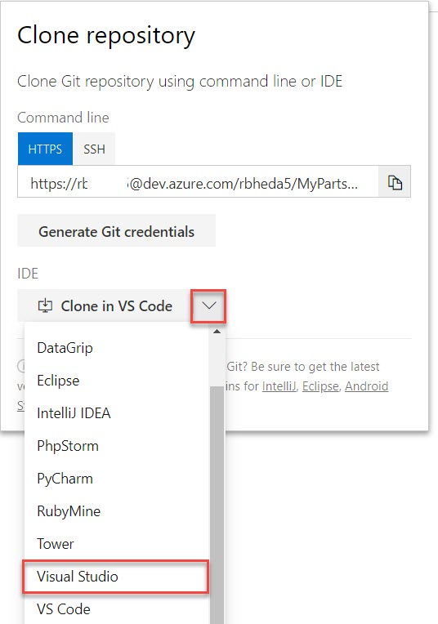

Step 19: Browser will be prompt and click on Open Microsoft Visual Studio Handler Selector

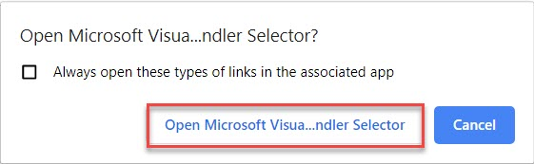

Step 20: Visual Studio will start and Azure DevOps Clone will load as below:

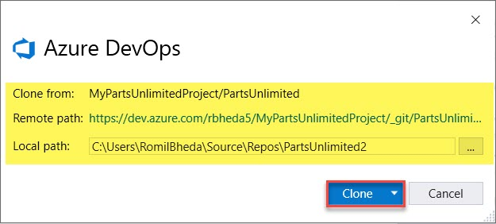

Step 21: Project will clone in Visual Studio.

Double click on PartsUnlimited.sln file

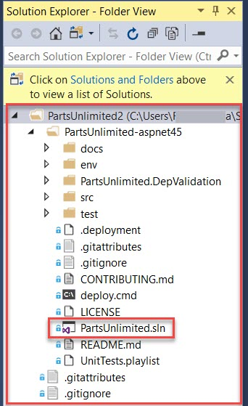

Step 22: Build and Run Project

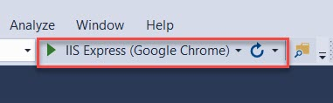

Step 23: Project will run in Localhost

http://localhost:5001

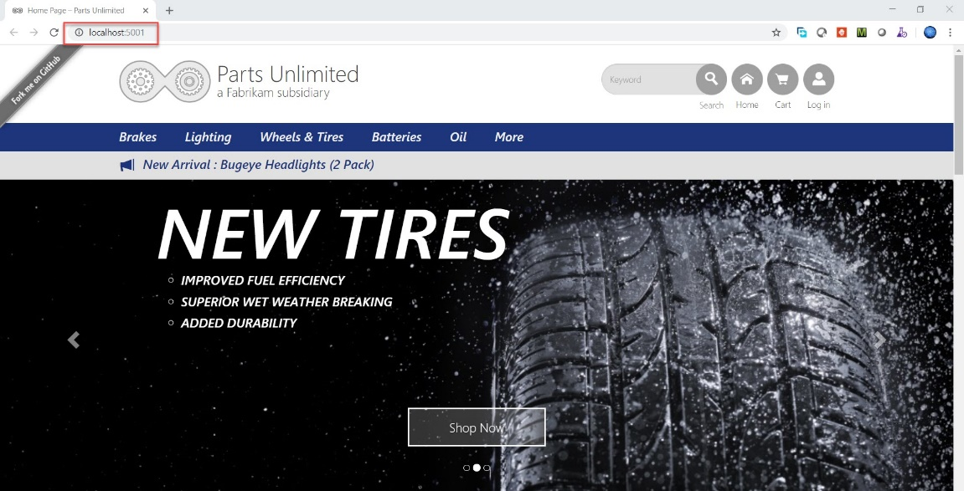

Step 24: Navigate to Test Extension and click on Start

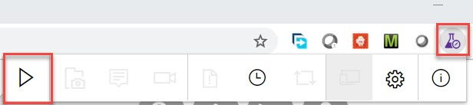

Step 25: First search with any product. Ex. jumper lead.

As a result, you will get as below:

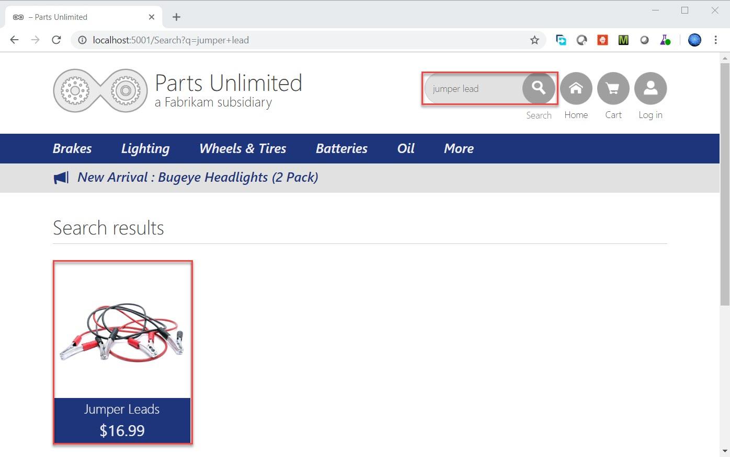

Step 26: Now search with different product name Ex. jumper leads

No result found.

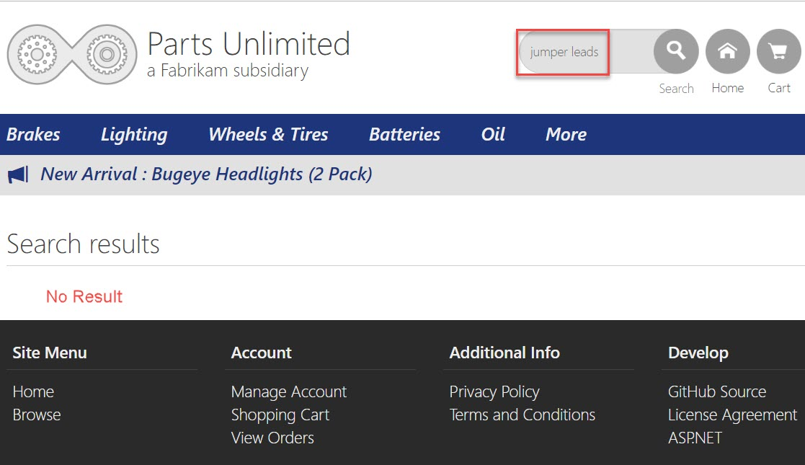

Step 27: Back to Test & Feedback Extension.

Click on Camera icon & select Browser option

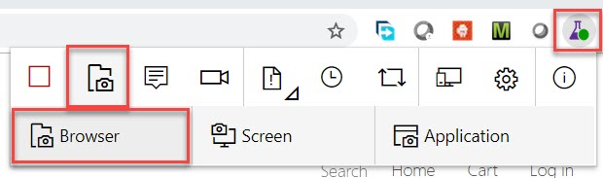

Step 28: Capture screenshot as below

Enter Comment and click on Blue area option

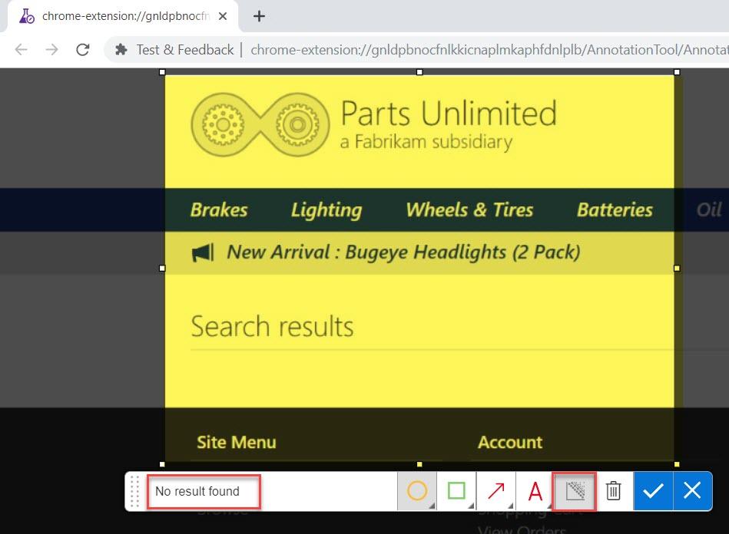

Step 29: Blur other text information due to security reason and complete this task.

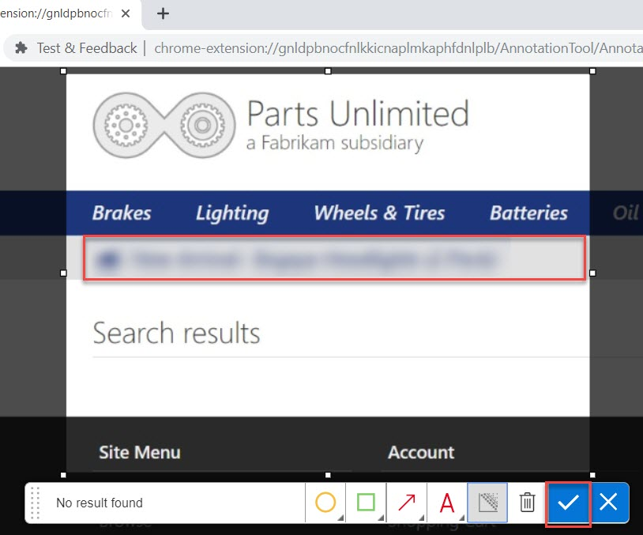

Step 30: Once again select Extension and Select Note option

Enter Note and Click on Save button.

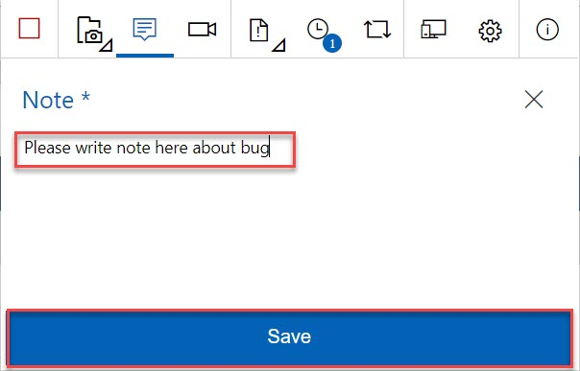

Step 31: Now for better understating recording is good option.

Select extension and click on recording option

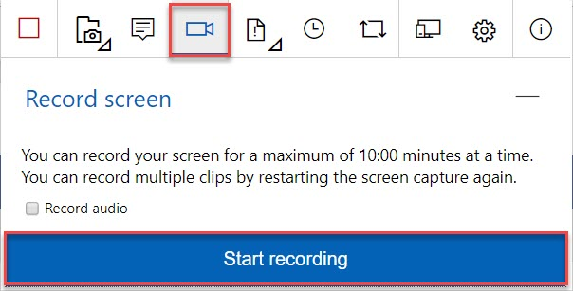

Step 32: Choose Application Window and Choose running project screen.

Click on Share button.

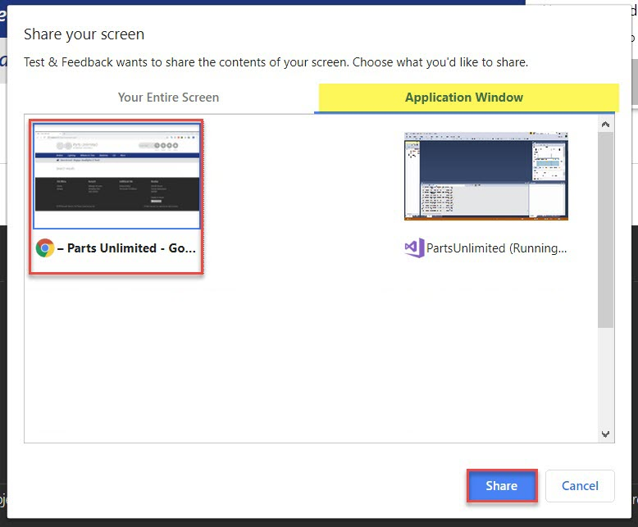

Step 33: Repeat same steps about search option

First search with jumper lead -> product will load

Second search with jumper leads -> No result found

After all steps click on Stop recording.

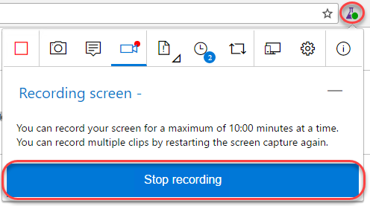

Step 34: Navigate to Timeline option and you can see all details available. Ex. Recording, Notes, Photo

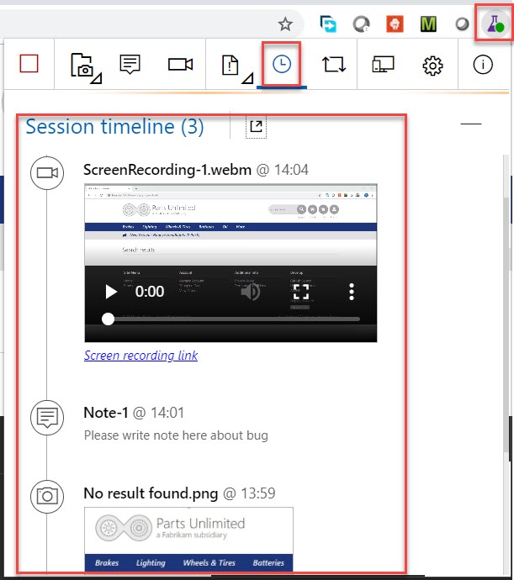

Step 35: Now time to Create Bug as well.

Select Bug option and Create bug

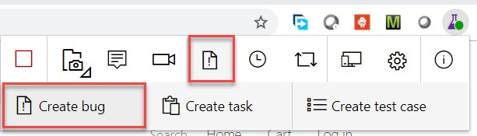

Step 36: Enter Bug Detail: Search for jumper lead – fails and Save

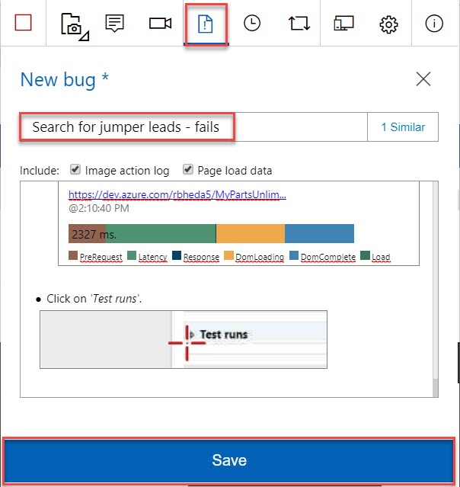

Step 37: Click on recently created bug

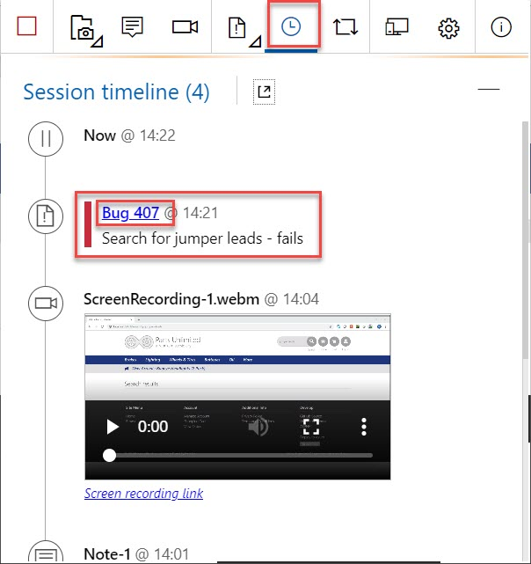

Step 38: All details available regarding recent bug

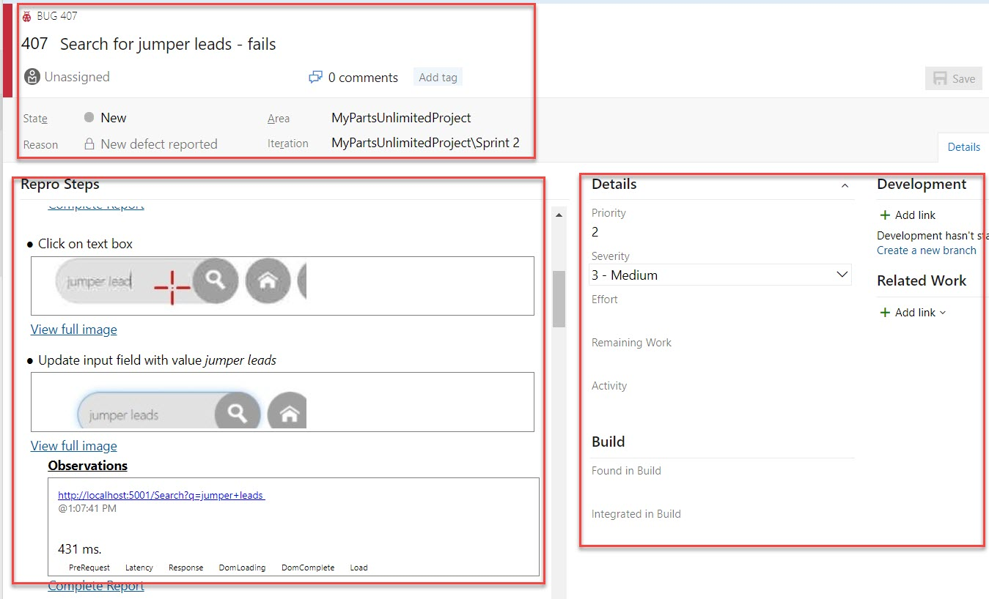

If all the process is complete, Click on Extension and Stop.

